**Stop-Process Custom Tool Setup Instructions**

1. In System Frontier, click on **Tools >** **Create tool**.

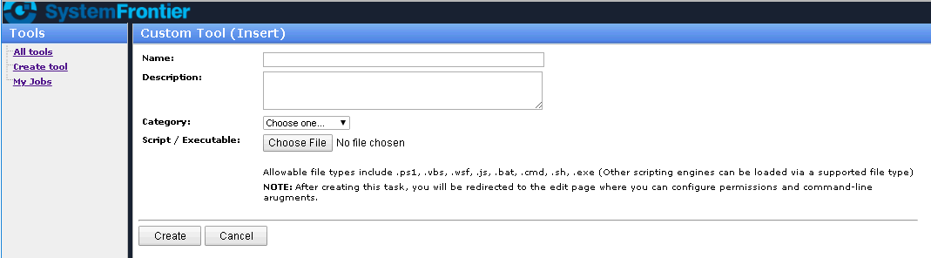

1. Enter the tool name:

**Stop-Process**

1. Enter the description:

**Stops a process on a computer.**

1. Select the appropriate category, then click **Choose File** to specify the applicable script to use for this tool. Be sure to select this file:

**Get-TimeInfo.ps1**

1. Click **Create**.
2. Once the tool is created, it will open up the **Custom Tool (Edit)** page.

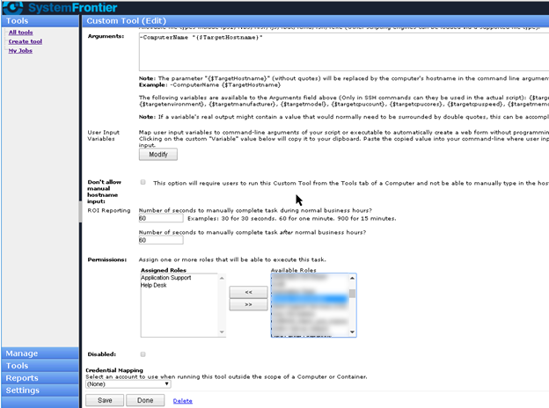

Scroll down to the Arguments section. For this tool, the only argument required will be the name of the computer. Within the Arguments field, type:

**-ComputerName "{$TargetHostname}"**

1. Select the Assigned Roles for this tool under the Permissions section. The roles selected will have access to run this tool.
2. Click **Save**.

The setup and configuration for this custom tool is complete.